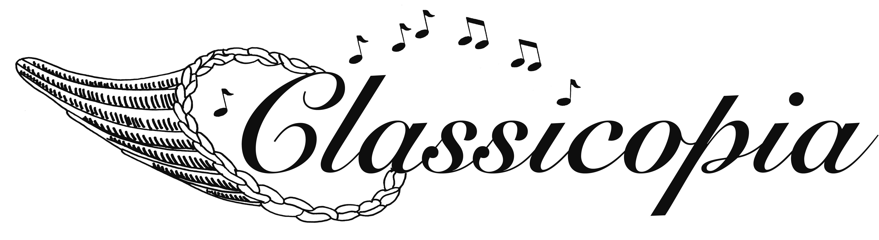

**Marcia Colligan, *President*; Daniel Weiser, *Artistic Director***

Go Tell It on the Mountain

***A Musical Celebration of African-American History Month in Spirituals and Ragtime Arrangements***

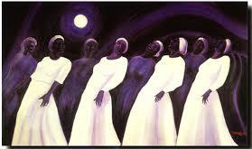**A person standing in front of a piano

Description generated with very high confidence**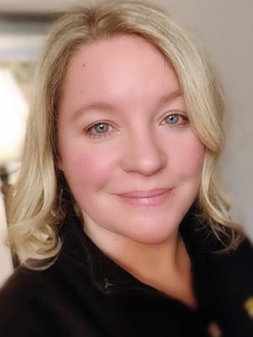

**Laura Compton,** *Mezzo-Soprano*

**Daniel Weiser,** *Piano*

**Saturday, February 15, at 7:30 pm**

**First Congregational Church of Lebanon**

**$20 suggested ($15 church members, children free)**

**All Are Welcome!**

**Music**

*at the*

**Meetinghouse**

*For more:* **603-643-3337/www.classicopia.org**

**First Congregational Church *of* Lebanon**

10 South Park St • PO Box 230 • Lebanon, NH 03766

(603) 448-4281 • www.fccleb.org • church@fccleb.org